
Pintlala Historical Association
P H
A
c/o Pintlala Public Library 255 Federal Road
Hope Hull, AL 36043
N E X T M E E T I N G
J
P
2 1 , 2 0 2 4
2 : 3 0 . .
B
C


Next Meeting:
July 21, 2024 at 2:30 p.m. Pintlala Baptist Church

Volume XXXVIII, Number 3 www.pintlalahistoricalassociation.com
c/o Pintlala Public Library 255 Federal Road
Hope Hull, Alabama 36043

July 2024

Join the Pintlala Historical Association Please mail completed form & dues to:

Pintlala Historical Association Ina Slade, Treasurer 15212 Highway 31
Hope Hull, Alabama 36043

Name Address
City, State Zip Phone (Home & Office)
E-Mail Address

Areas of Interest

If you are interested in genealogy, please indicate family surnames

$15.00 Annual Dues

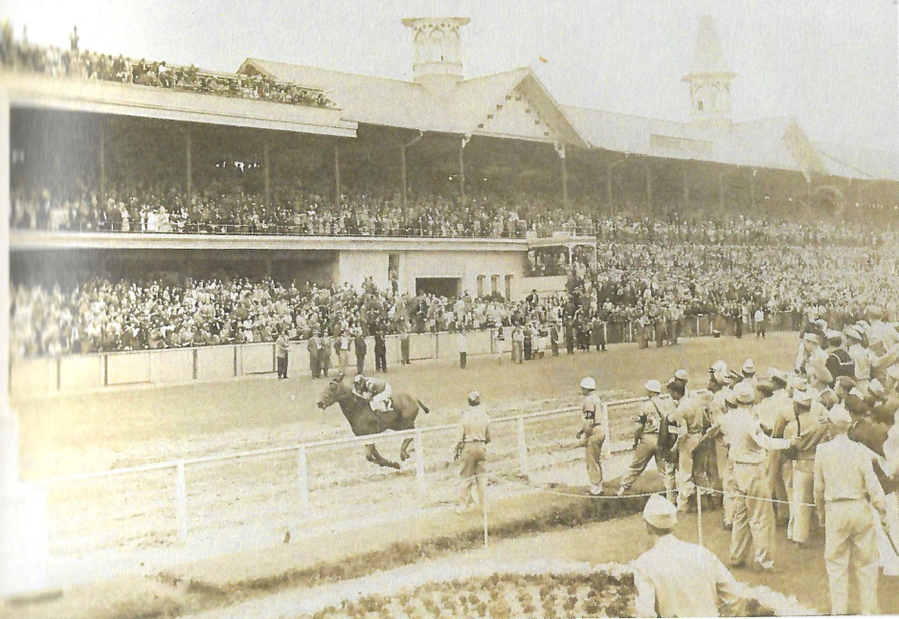
The horse, Hoop, Jr., pictured at Churchill Downs racetrack on the way to being the winner of the Kentucky Derby in 1945.
Photo courtesy Wanda Quigley. See page 9 for more information.
Vice President’s Greeting Page 2
New Members Page 2
Correction Page 2
July Program Page 2
Union Academy, Fleta Alabama Page 3
Hoop, Jr. and the Kentucky Derby Page 9
History of the Henry Family 4th Barbeque Page 11
C
T
President ....................Gary Burton (334)288-7414
Vice President &
Program Chairperson .Alice T. Carter (334)281-3708
Secretary....................Karon Bailey (334)224-9631
Treasurer....................Ina Slade (334)284-0337
Parliamentarian ..........Jack Hornady (334)396-2130
Members at Large
Place 1 ........Patsy Davis (334)220-7004
Place 2 ........Daisy Anne Brady (334)398-0636
Place 3 ........Frank Ellis (334)315-8927
Place 4 ........Alan Davis (334)270-8657
Newsletter Designer Angelique Pugh
2024 O

VICE PRESIDENT’S GREETING
As the July 2024 PHA Newsletter was being prepared for the printer, word came that our president, Gary Burton’s twin brother, Lary Burton, had passed away on July 1. Our thoughts and prayers are with the extended Burton fami- ly.
In lieu of a President’s Message, readers will find a variety of patriotic writings on which to ponder and draw wisdom. Bless you Gary during this difficult time.
History of the Henry Family July 4th Barbeque By Iva Kate Hall Hopper
June 29, 2024
My earliest memories of Iva Garrett and James Porter Henry, my grandparents, include an every-Sunday feast of a dinner at their old home on U.S. 31, with the "Twin Oaks" in the front yard. I remember that Grandaddy Henry was the one who always bought the groceries, because he was frequently in Montgomery for various meetings. We're not sure when the annual Henry Family 4th of July Barbeque and Henry Family Reunion had its initial start, but I remember, as a small girl, helping my father, Joe Hall, skin, and dress rabbits for a 4th of

I Hear America Singing by Walt Whitman,1819-1892
I hear America singing, the varied carols I hear,
Those of mechanics, each one singing his as it should be blithe and strong.
The carpenter singing his as h measures his plank or beam,
The mason singing his as he makes ready for work, or leaves off work,
The boatman singing what belongs to him in his boat, the deckhand singing on the steamboat, deck,
The shoemaker singing as he sits on his bench, the hatter singing as he stands,
The wood-cutter’s song, the ploughboy’s on his way to the morning, or at noon intermission or at sundown,
The delicious singing of the mother, or of the girl sewing or washing,
Each singing what belongs, to him or her and to none else,
The day what belongs to the day—at night the party of young Fellows, robust, friendly,
Singing with open mouths their strong melodious songs.
God send us men with hearts ablaze All truth to love, all wrong to hate; These are the patriots nations need, These are the bulwark of the state.
Author: Frederick A. Gillman

Sometimes people call me an idealist. Well, that is the way I know I am American.
Author: Woodrow Wilson

When an American says he loves his country, he means not only that he loves the New England hills, the prairies glistening in the sun, the wide and rising plains, the great mountains, and the sea. He means that he loves the inner air, an inner light in which freedom lives and in which a man can draw a breath of self-respect.
Author: Adlai Stevenson

Quotes from Gillman, Wilson and Stevenson appear in
Harvest of Gold,
published by the C. R. Gibson Company in 1973
July at our old house on Teague Road (now Hyundai Blvd). We would put the dressed rabbits into a ten-gallon milk can filled with cold water, and then the can was put into a huge cooler in the "milk room", where they were stored until the time came for barbequing the next day. Later, in 1956 I recall a huge "send-off" barbeque at Granny and Grandaddy's home when Granny's nephew S.F. Timmerman was about to leave as a missionary to Belgium. According to a recent phone conversation with S.F.'s youngest brother, Garrett, all of Granny's sib- lings, Dr. DeWitt, Fannie, Blanche, and Will Davis and their families were there, making it a huge crowd. Garrett recalls that tables and chairs were all over the back yard, and in a huge cast-iron pot (which was also used at other times in canning vegetables and peaches), the "farm help" was making a delicious camp stew.
In 1958 Uncle Davis was discharged from the Army in Pennsylvania, so he, Aunt Margery and Garry moved into the old Henry home, and Granny and Grandaddy moved to their new brick home just a few yards north of the old one. One Sunday I distinctly recall Grandaddy being so concerned about difficulties with finishing the patio and the new barbeque pit in time for the July 4th ! But it was finished in time! Granny made a wonderful camp stew, and Grandaddy made his traditional hot sauce. (There's a story about this hot sauce!)
Jim Henry, III recalls that his family (Uncle Jamie and Aunt Jean) hosted the BBQ three times—once around two giant cottonwood trees by the big pond on their land near Sellers. He and Laslie camped out and barbe- qued a wild pig fattened by acorns. Jim says it was good, and he remembers that the little ones played in the pond, and that Granny was terrified that one of them might drown. Another reunion took place at their very small cabin in Sellers, and the third in the 60's at their Teague Road home.
Papa Joe (my father) purchased the farm on the Wasden Road in Hope Hull sometime in 1964. There was a very small, rough hunting cabin on this farm, and soon the cabin was upgraded. June 3, 1965, is the date in- scribed in the concrete, which was poured for the large, front porch of "the Cabin". A barbeque pit was quickly

Pintlala Historical Association Program for July 21, 2024
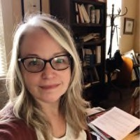
Pintlala Historical Association will meet on Sun- day, July 21 at 2:30 in the Fellowship Hall of Pintlala Baptist Church.

WELCOME NEW MEMBERS
Earl Russell Ramer, Alabama
Norma Britt Robertson Mesquite, Texas
Our speaker will be Christy Anderson who current- ly works at the Alabama Historical Commission as State Coordinator for the National Register of His- toric Places. Christy also served as a long-range planner with the City of Montgomery which evolved into the role of Historic Preservation Coor- dinator for the City. She has served on boards of several Montgomery organizations such as Capri Community Film Society, Citizens Advisory Com-
Correction: Pintlala Historical Association Newsletter, Volume XXXVIII, Number 2, April 2024, Page 9: Montgomery County Commissioner Fred A. Sellers who served on the Commission 1964-1968 was born 1909 and
died 1984.
Christy Anderson, Alabama Coordinator mission for Pre-trial Diversion, Landmarks Foun-
for the National Register of Historic Plac-
added, and at Grandaddys insistence, the shed over the pit was expanded (there's another story there!), and for the past 59 years, with three exceptions, this is where the Reunion and Barbeque has taken place. One year, six pigs were cooked on an "extended pit" made from an old iron gate on top of concrete blocks. In 1974, Dwight and Patsy Davis moved into their new house on Felder Road, and for the next two years, the event was held there. One of those years, Everlie put up a huge balloon-arch decoration. In 2002 Amy and Mike Belcher hosted at their new home across from Patsy. It was a hot day! On that day Casey Clark Cranford told me I was too OLD to be in charge of the parade, so NOW she and Brittany Davis Ashley are doing a better job!!
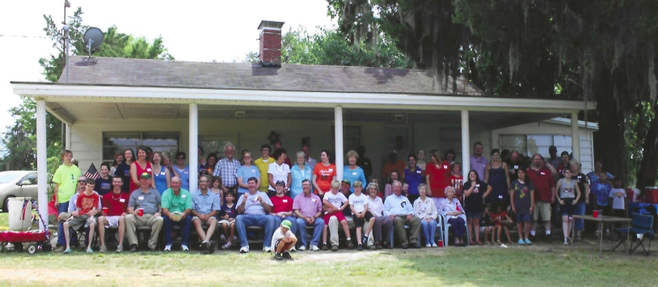
I must add that the approximately 150 descendants of James Porter and Iva Garrett Henry are a coopera- tive, loving, generous, happy, Christ- like bunch to work with--even when asked to take the 12 AM to 2 AM shift to watch the pig! We owe our
great appreciation to ail those who

es.
dation, Montgomery County Historical Society and serves on the vestry at St. John’s Episcopal Church.
work so hard to make this celebra- tion a huge success, especially Laslie Hall and his family. We ask

Christy and her husband, Rich, have spent the last 20 years renovating historic houses in the Capitol Heights neighborhood. They are currently completing reno- vations on a country home on Mt. Zion Road, Montgomery County, Alabama.
Documenting the Architecture of the Everyday in Alabama will be Christy’s program topic. Please join us for this enjoyable program and bring friends!
God's blessing on this reunion and on us all and pray that this great family BBQ tradition and faithfulness to God continues through the future generations!

Henry Family, July 2023

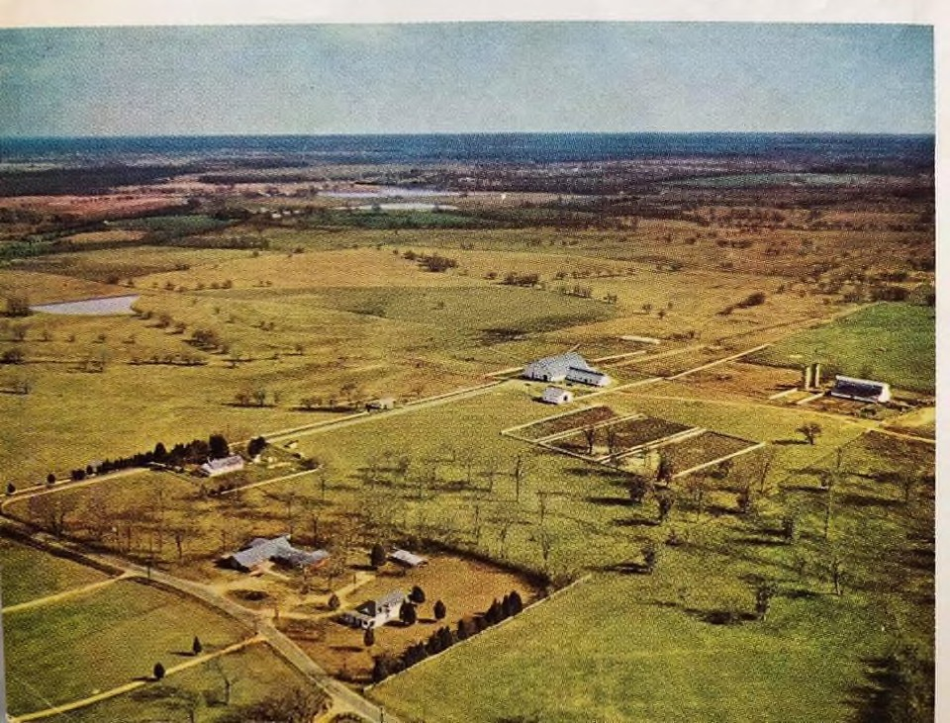
Union Academy Fleta, Alabama
Hooper Barn
Arial photograph of Wasden Road, date unknown photo courtesy, Angelique Pugh
Alice Carter
William F. Feagin, Montgomery County Superintendent of Education- Elect authored a report to citizens of Montgomery County and the Board of Education in 1917. This report was titled A School Map of Montgomery County and Views of the Rural School Buildings for White Children. A hand drawn map illustrates the locations of these schools. Union Academy is shown at the intersection of Pettus Road (County Road 19) and Union Academy/Ada Road. There is a four way stop at this intersection. Drivers seeking the site of Union Acad- emy should turn right and proceed less than ¼ of a mile on Union Academy/Ada Road. The school is thought to have been located on the left side of this road. Today there is no school building at the site. At some point, likely in the 1950s, a community bar-b-que pit was constructed at the old school location. Mr. Feagin’s report con- tains sketches of rural schools discussed in his information.
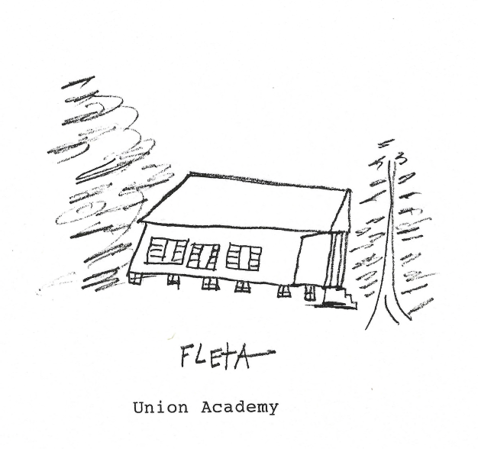
Additional facts includ- ed in Feagin’s report are presented in charts. Union Acade- my or Fleta School is listed as a one- teacher, church style

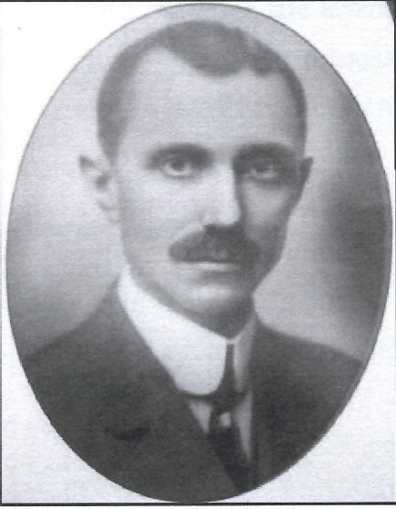
William F. Feagin, 1917

Acknowledgement:
Thanks to Fred Hooper’s grandson, Buddy Green of Hope Hull for information on the famous horse.

Internet Sources:
https://en.wikipedia.org/wiki/Kentucky-Derby; accessed June 16, 2024
https://www.britannica.com/print/article/315057; accessed June 15, 2024 https://www.findagrave.com/memorial/169119399/hoop_jr https://www.krqe.com/photo-galleries/photos-the-kentucky-derby-through-the-years/
building on level ground, furnished with 33 manufactured desks and 90 square feet of blackboard. The building was valued at $500.00.
Forty-seven one and two teacher schools in Montgomery County were consolidated into eight schools in 1922. These eight schools were: Capital Heights, Catoma, Chisholm, Clo- verdale, Pike Road, Pine Level, Ramer and Pintlala. It is my assumption that this was the year for the closing of Union Academy.
Pintlala Historical Association founder, Ethel Tankersley Todd, interviewed her father, Dr. William Tankersley, in 1945, regarding early schools in the Pintlala vicinity. Her notes are helpful in documenting the existence of Union Academy in Fleta, Alabama. William Tankers- ley stated that the school was built in 1845. Documentation for this date has not been located. The earliest date this writer has found associated with Union Academy was the date on a contract between Rebecca McPherson and “subscribers” dated March 26, 1864. She never taught at Union Academy as she married my great grandfather in May, 1864.
List of Union Academy teachers as recalled by Dr. William Tankersley in 1945, however, no years for their service were provided :

Book
Heller, Bill. The Extraordinary Life of a Thoroughbred Legend. Printed by Digital Publishing of Florida, 2021.
Joe Howell
Dan Tharon (Tharin) Fannie Amason Florence Supple Kate Smith
Joe Harrison Ed Wood
James Tankersley Dave Murrell Ernest Stough
Zelma Tankersley Jessie Mae Supple Sarah Whetstone Albert Barnett Leonard Denny
Kittye Brown (McIntyre) Lucille Duncan
Bessie Green (Hawthorne)
Sadie Huckabee (Crenshaw)
LaFayette Duncan

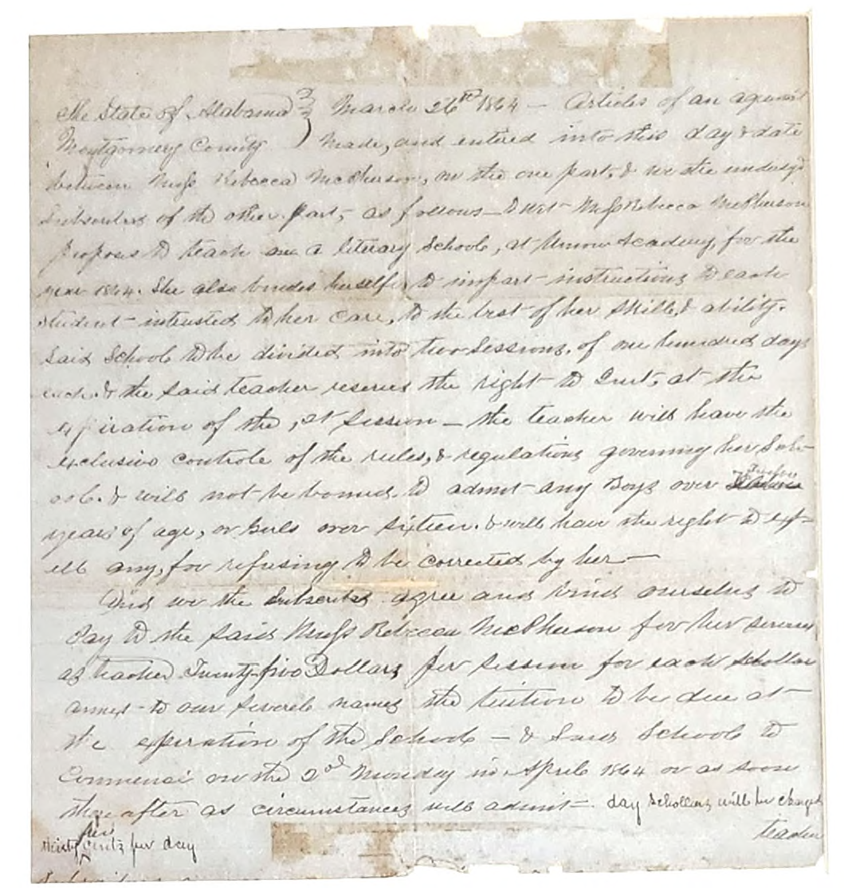
Image and transcription of Rebecca McPherson contract for Union Academy, 1864
Hoop, Jr. and the Kentucky Derby Alice Carter
The Kentucky Derby horse race is run at Churchill Downs in Louisville, Kentucky and is traditionally held on the first Saturday in May. The horses in this race are three-year-old thoroughbreds who run for a distance of 1 ¼ miles. The first Kentucky Derby was run in 1875.
The 2024 Kentucky Derby, televised by NBC, was an exciting event for racing fans as they watched Mystik Dan win by a nose. For this viewer thoughts of reports from the 1945 Derby came to mind due to its ties to Hope Hull, Alabama.
The 1945 Kentucky Derby was won by Hoop, Jr. a horse owned by Fred W. Hooper of Hope Hull, Ala- bama. The horse had been trained by Ivan H. Parke at Hooper’s Hope Hull farm and was ridden in the Der- by by jockey, Eddie Arcaro. Only one week later, Hoop, Jr. competed in the 55th Preakness race held in Baltimore, Maryland. During this race, Hooper’s horse finished in second place despite a tendon injury in his left leg. Tragically, the injury proved to be career ending as far as racing was concerned. Hoop, Jr. was brought back to his old training grounds in 1946, not as a race horse but a stallion that ultimately sired 113 named foals.
In 1964 the beloved horse, Hoop, Jr., passed away at 22 years of age in one of Fred Hooper’s barns on Wasden Road, Hope Hull and was buried there. Some years later, the horses remains were moved to Fred and Wanda Hooper’s Ocala, Florida farm. To mark Fred’s 75th birthday his four children gifted him with a marble headstone for Hoop Jr.’s grave.
An interesting note on Churchill Downs itself is that the grandson of the famous explorer William Clark, (Lewis and Clark Expedition, 1804-1805) Meriwether Lewis Clark, established a racetrack in Louisville on land owned by his uncles, John and Henry Churchill. Ultimately, the track was named for the two gentle- men.

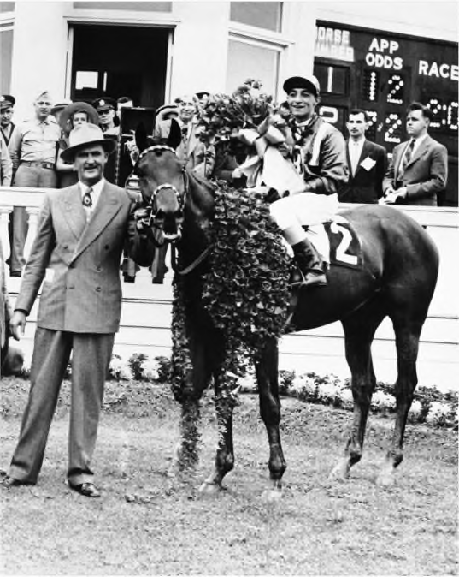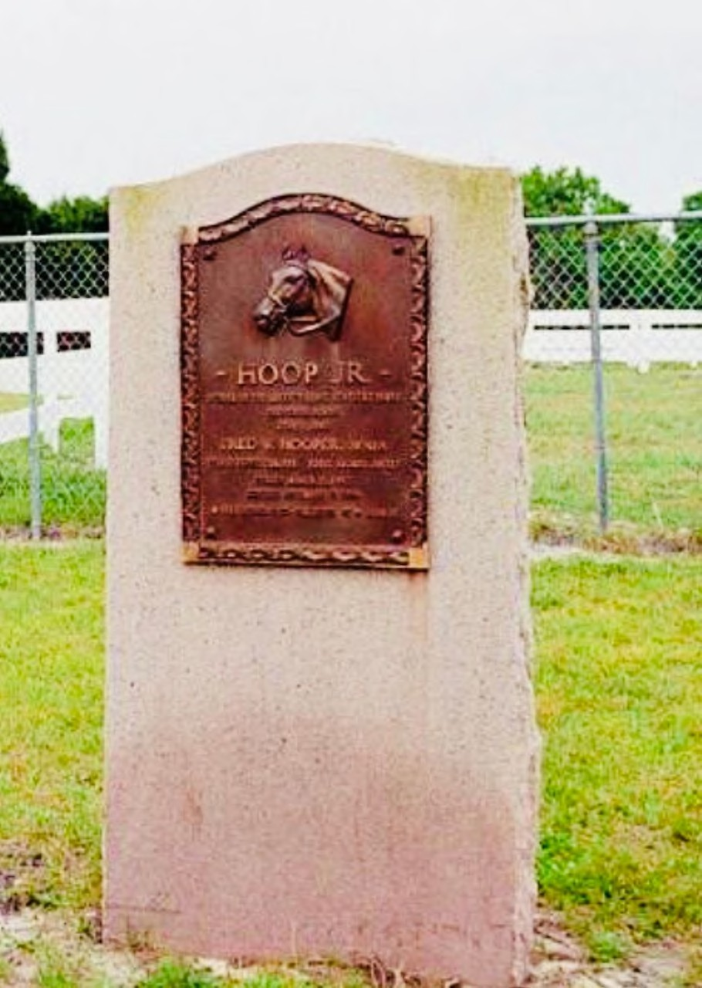

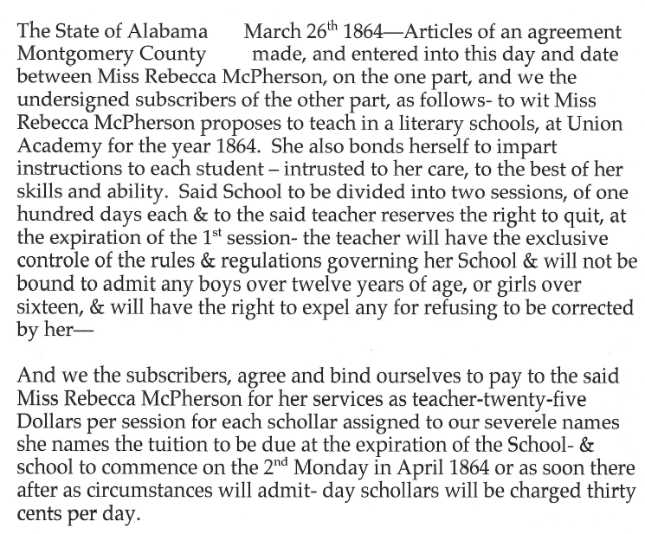
In this June 9, 1945, file photo, horse owner F.W. Hooper with Ken- tucky Derby winner Hoop Jr., jockey Eddie Arcaro up, in the winners circle at Churchill Downs in Louisville, Ky. (AP Photo/File)
Grave of Hoop Jr. in Ocala, Florida

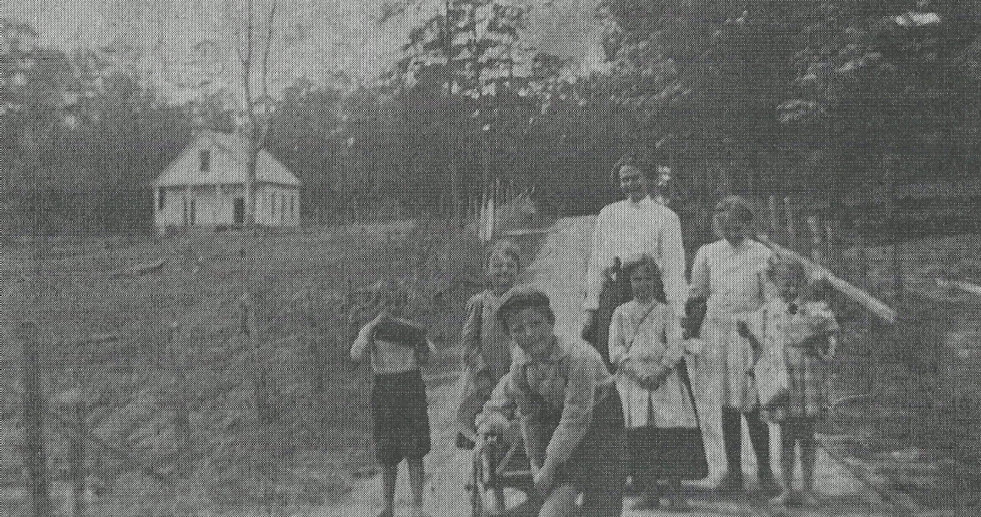
The next dates associated with Union Academy are on photographs provided by Tryon McLaney and Pintlala Historical Association files.

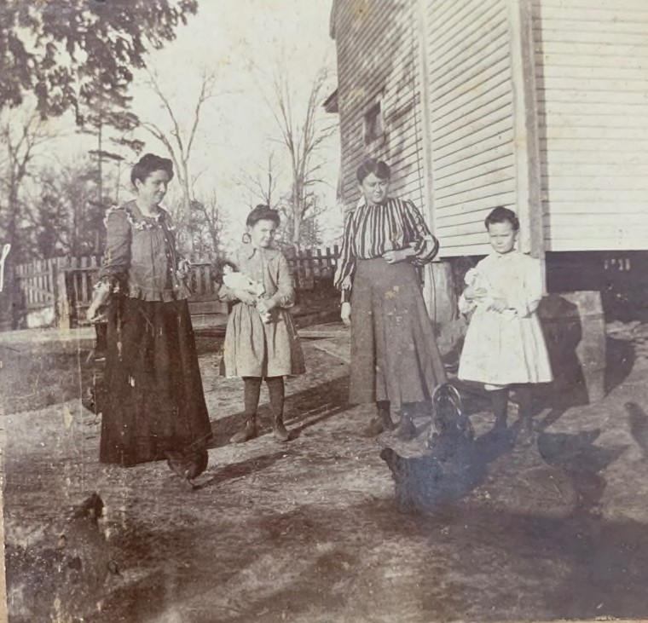
Thought to be Mrs. Zeverah Duncan and unidentified children standing in the Union Academy/Ada Road with Union Academy in the background. Courtesy Tryon McLaney

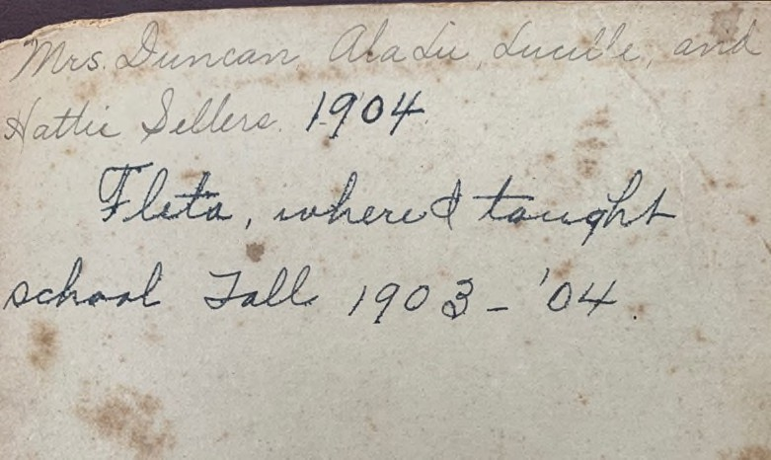
If any readers of this publication or their families find information on Union Academy in family archives, please contact Pintlala Historial Association.

Acknowledgement
Thanks to Tryon McLaney of Montgomery for searching his Fleta Community files and sharing photographs of Union Academy or Union Academy associated photograph.

1904 photograph, front and back: Zeverah Duncan (Mrs. Thomas Duncan), daughters: AlaLu and Lucille and her sister Hattie Sellers. Handwritten information on the back of this photograph was likely by Zeve- rah Duncan. Courtesy Tryon McLaney

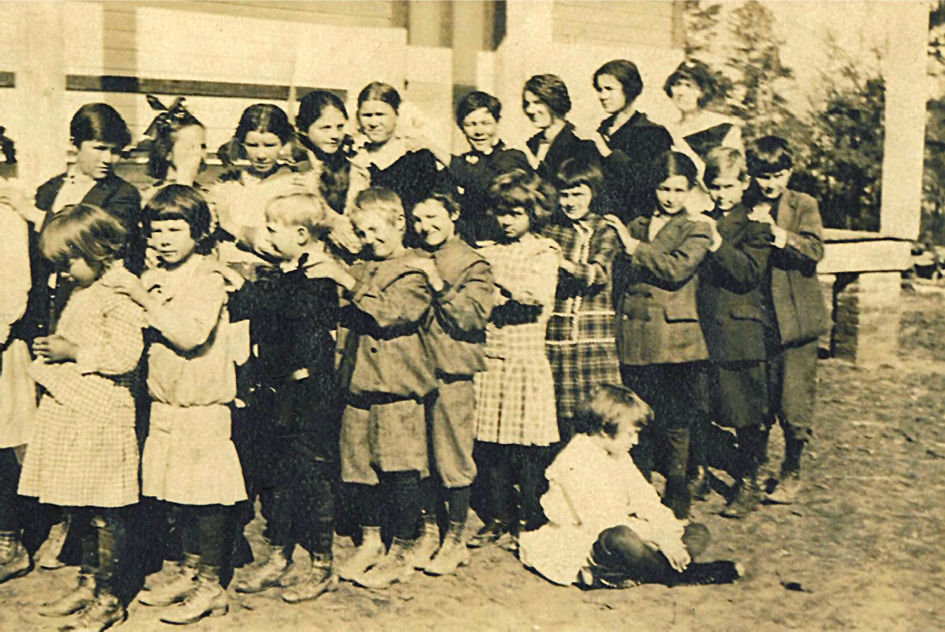
Undated photographs associated with Union Academy, Fleta, Alabama

1911 photograph of Union Academy students, circa 1911, from teacher Bessie Green (Hawthorne) with students listed by Vera Sellers Kraus. It was found in PHA files at Pintlala Library: front row, L to R: Inez Poole, Lucile Stockard, Willie Joe Scaife, Thomas Sansom, Jessie Sansom, Vera Sellers, Louise Rowe, George Edwards, Cecil Vickers, Herbert Rowe. Second Row, L to R: Willie Jim Edwards, Beuna M. Dun- can, Ruby Stockard, Willie Lee Skinner, Tisha Poole, Eva Poole, Roxie Stockard, Thena (?) Rowe and Mary Lou Poole
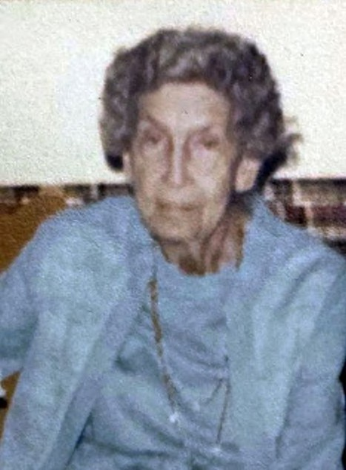
Bessie Green (Hawthorne), teacher at Union Academy Photo courtesy Mike Hawthorne

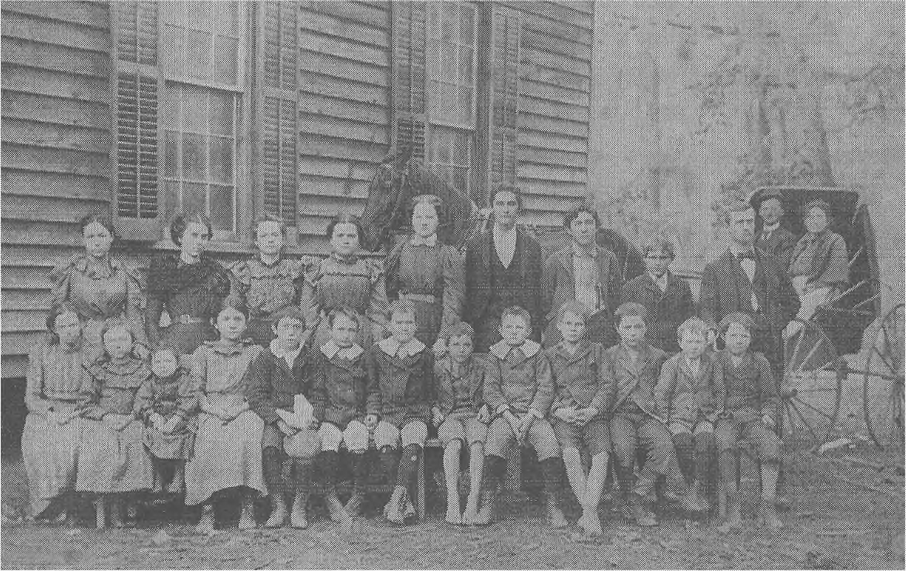
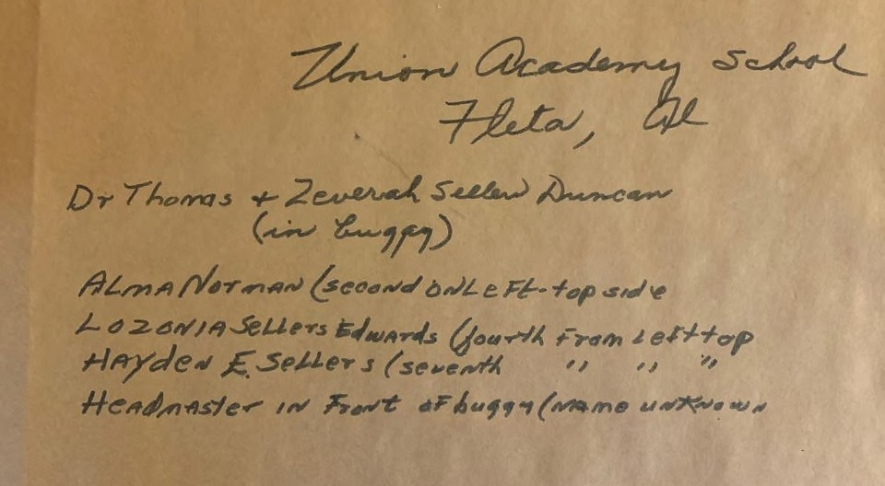
Dr. Thomas Duncan and wife Zeverah in buggy, Headmaster (name unknown) in front of buggy. Students identified: Alma Norman (second on left, top side); Lozonia Sellers Edwards, (4th from left, top row); Hay- den E. Sellers (7th from left, top row). Courtesy Tryon McLaney

